1.users into salesforce from an external system?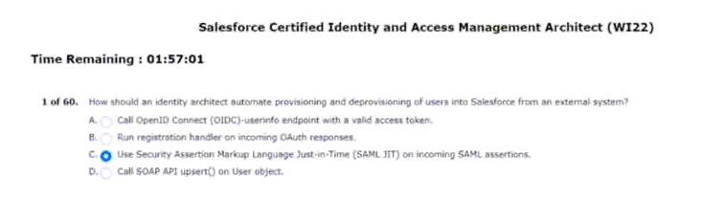
2.brand experience in salesforce is presented?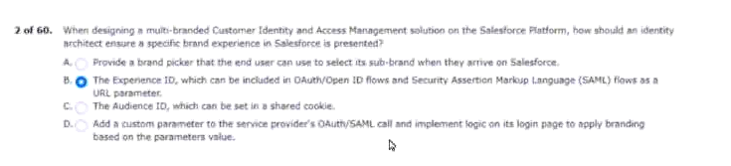
3.registration experience on salesforce experience cloud.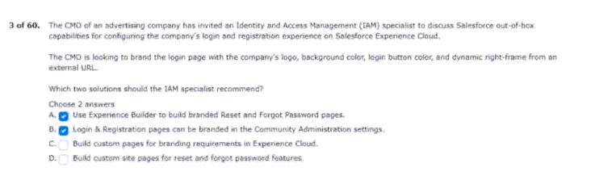
4.security assertion markup language (saml) identity provider. 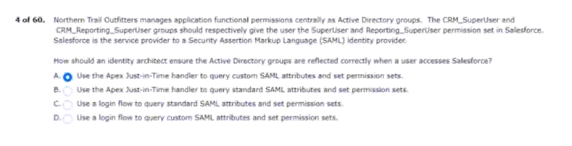
5.with its experience cloud customer portal.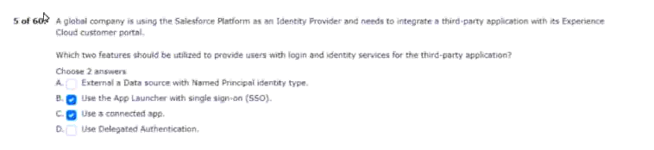
6.users will view a recognizable nto-branded page.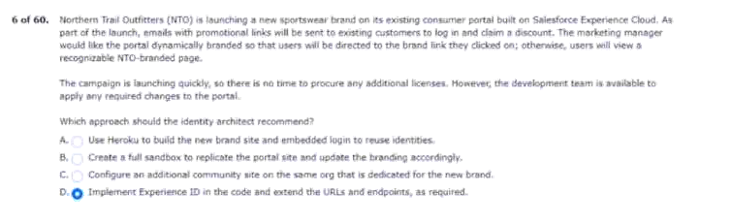
7.revoke the device from which users log in.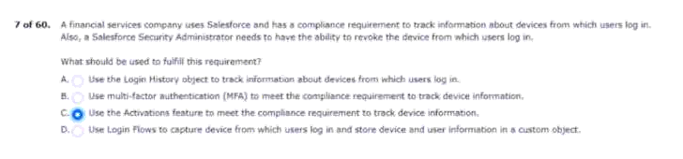
8.replay detected and assertion invalid login errors.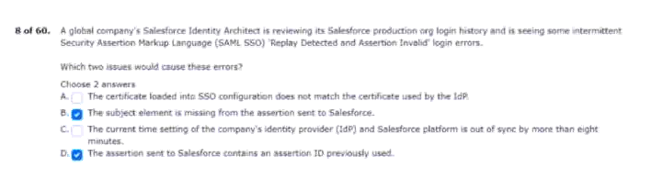
9.new customers on the website.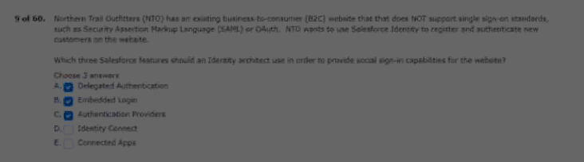
10.to register and access.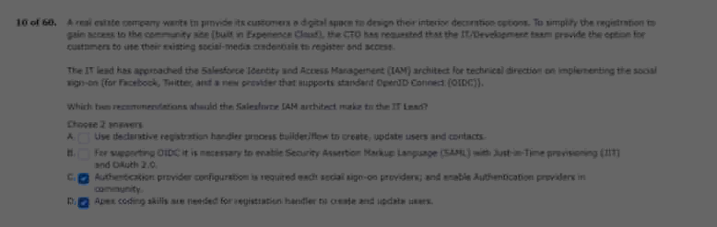
11.once they have logged into salesforce.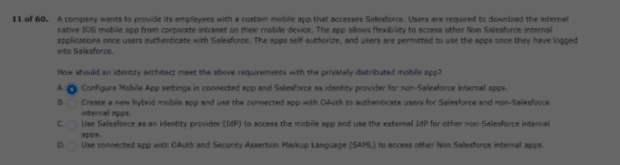
12.could indicate a breach has occured.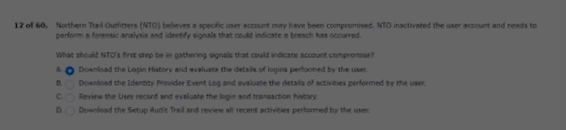
13.protected resource in a flexible way.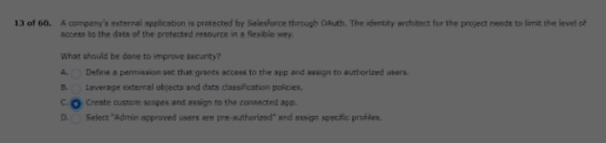
14.to use personal accounts.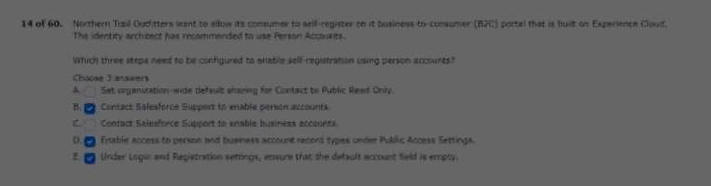
15.with a google workspace (formerly known as G suite).
Upon similar actions in salesforce.
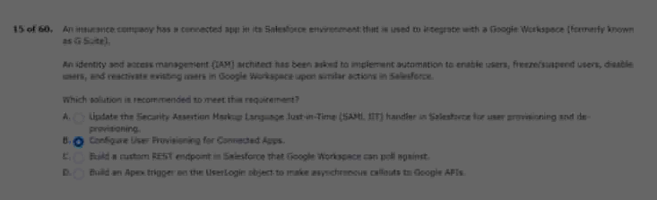
16.in the login history can help.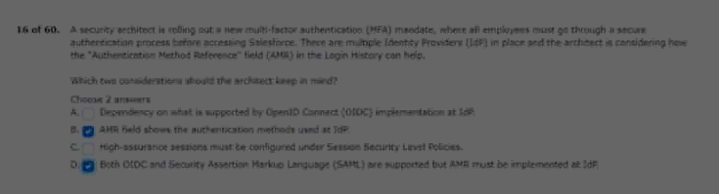
17.application using salesforce identity.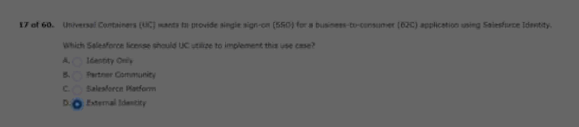
18.the following are the requirements for the solution:
Every time they use the app.
Salesforce rest api.
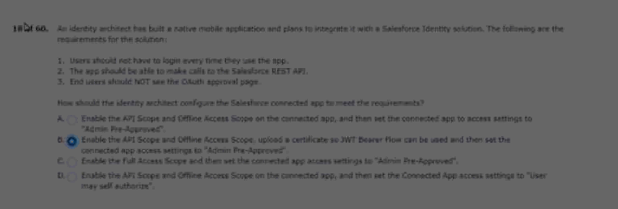
19.partner event. 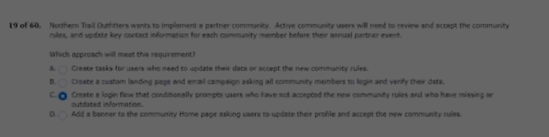
20.identity provider which includes built in mfa.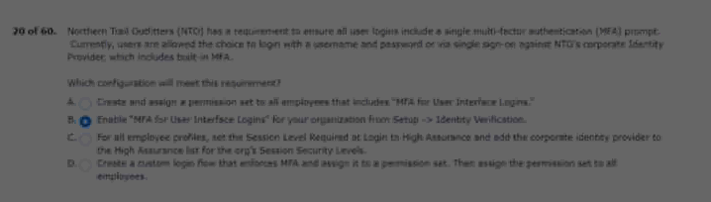
21.api calls against the rest api.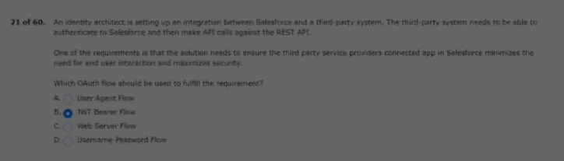
22.and salesforce sales cloud.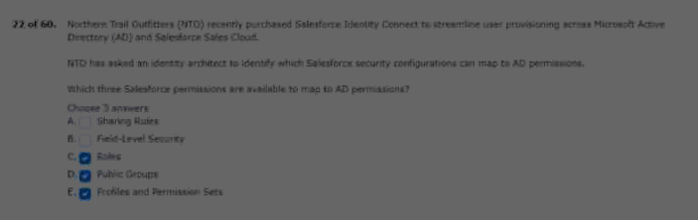
23.when provided access to the community.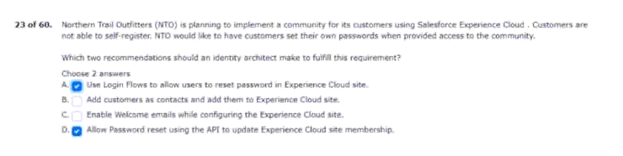
24.error messages when logging in.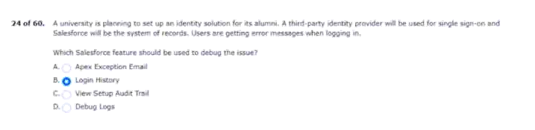
25.licenses have been purchased for the project.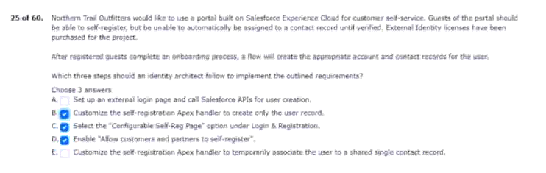
26.salesforce under single sign-on (sso).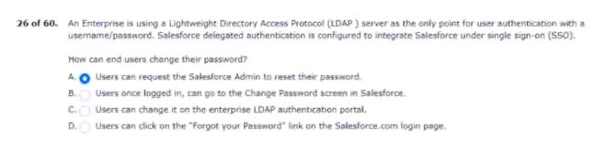
27.and has the following requirements.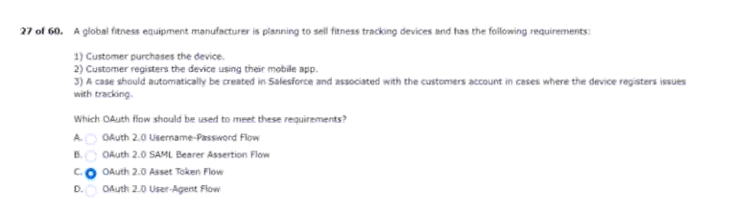
28.users without contact information.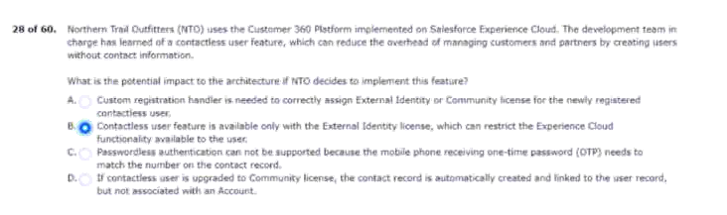
29.disabled in the corporate LDAP directory.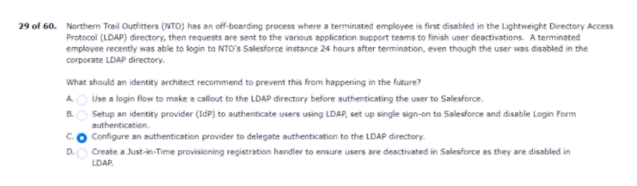
30.or curb fraudulent activity.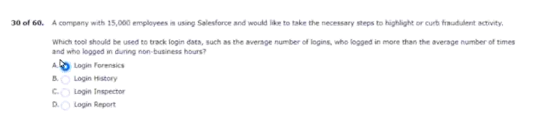
31.will be used for identity verification.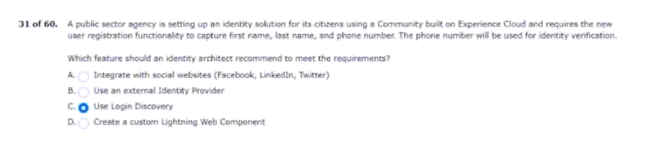
32.have no direct user input or output capabilities.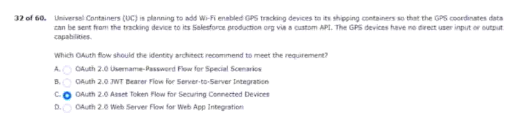
33.control access to the custom app.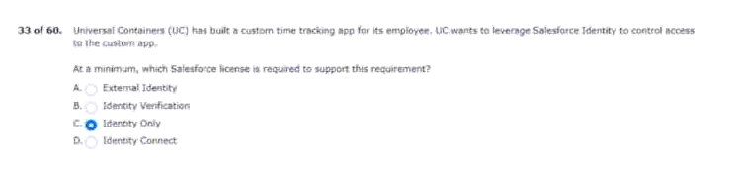
34.with their facebook or linkedin credentials.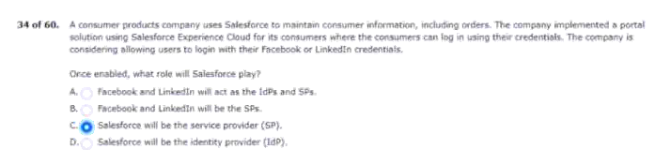
35.single sign-on process to salesforce.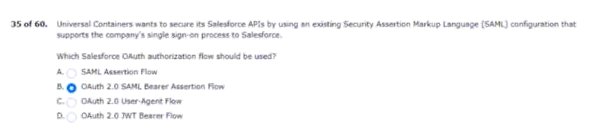
36.retunred to the wellness application in an id token.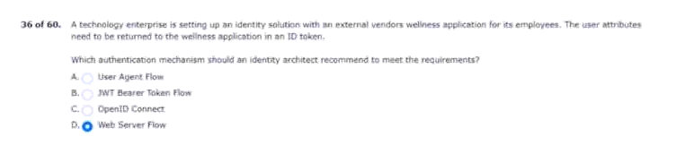
37.employee portal only supports oauth.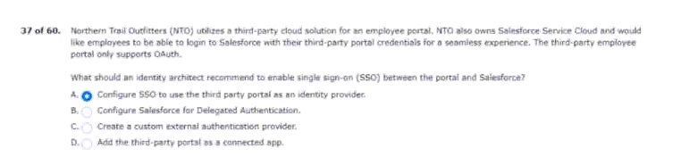
38.uc allows guest checkout.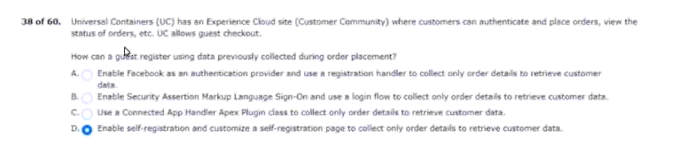
39.users to take specific actions in salesforce.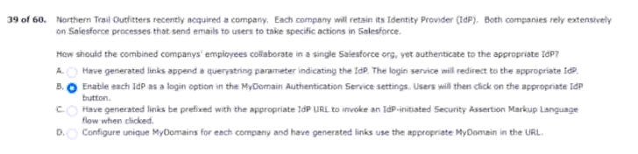
40.which login experience to use for the site.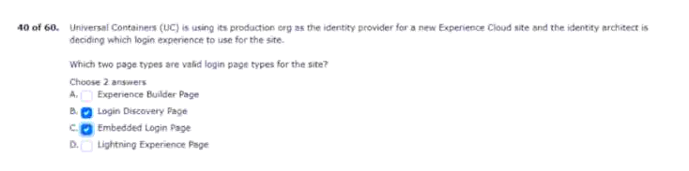
41.permission sets in salesforce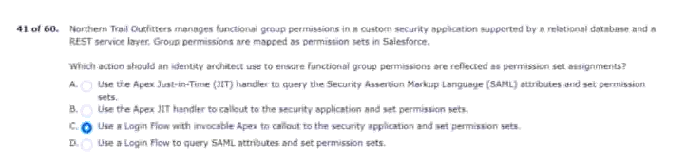
42.by all applications as follows.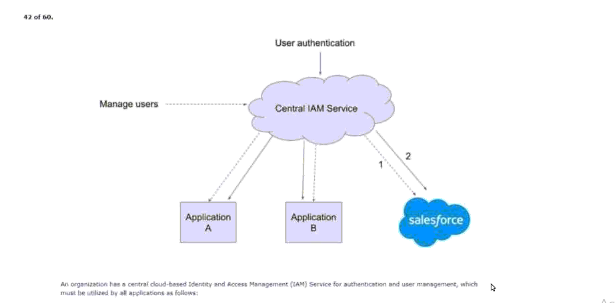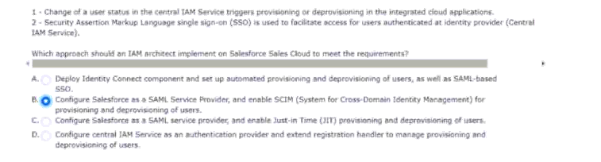
43.actions for the authorization flow.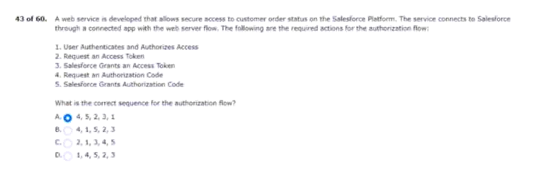
44.that is only accessible via a soap webservice.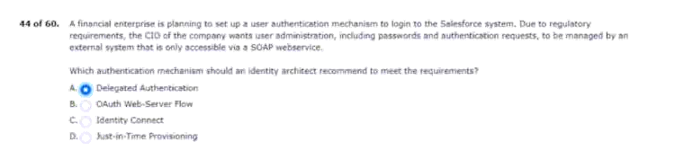
45.request content will be altered.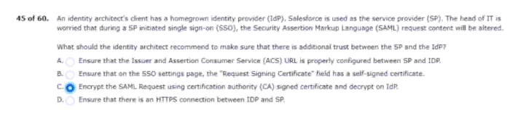
46.the agent role and permission sets.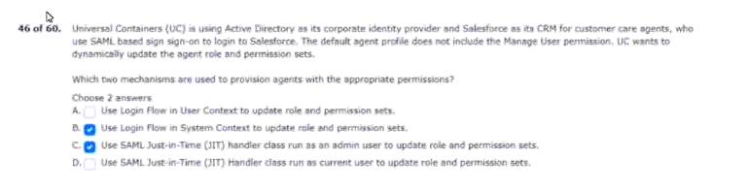
47.mobile app or reauthenticate for 3 months.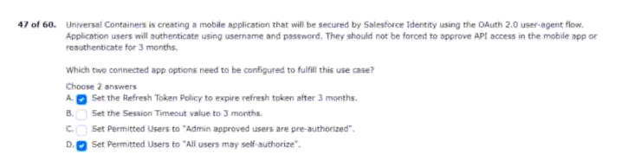
48.they have the following requirements.
Provide access to their partner network.
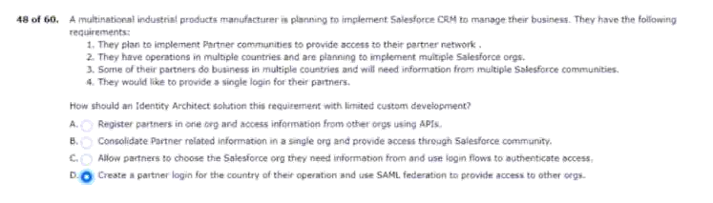
49.employees are unable to use mobile vpn.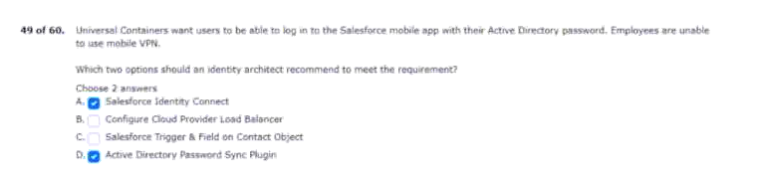
50.systems and formats.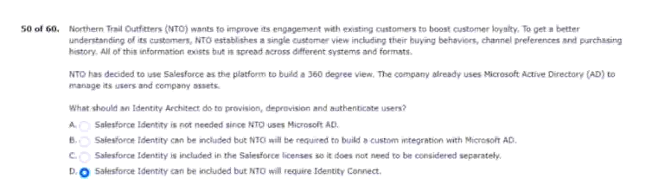
51.and openid connect(oidc).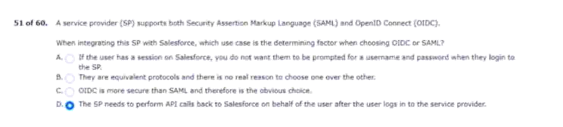
52.to access salesforce records on their behalf.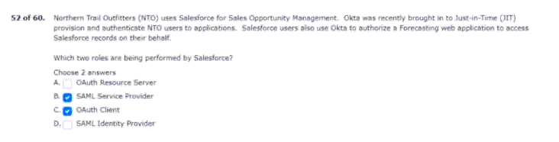
53.scheduled pickup dates from their calendar.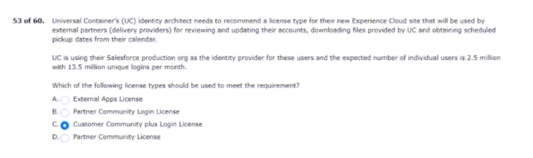
54.is currently used to authenticate users.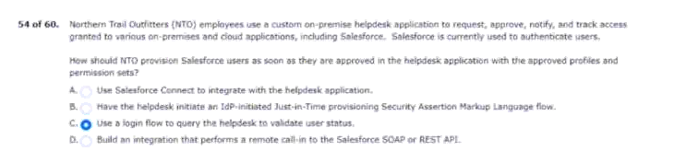
55.flow uses the oauth 2.0 authorization code grant type.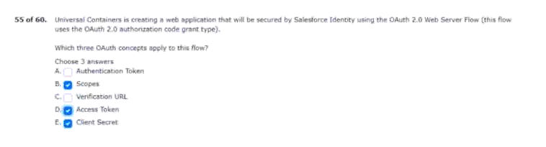
56.users access their app from salesforce.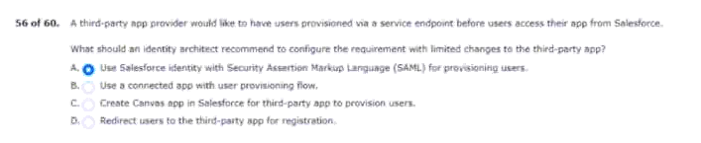
57.community licences in all orgs.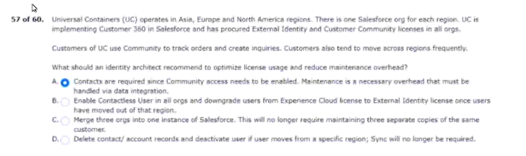
58.distributed as a private app.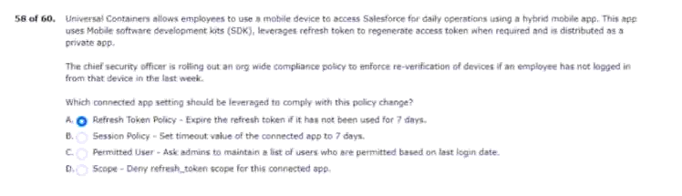
59.credentials for ease of use.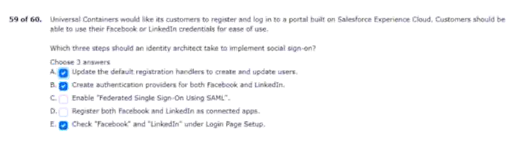
60.from an identity architect to resolve the issue.